**Task 1:** Write a multithreaded OpenMP C program for performing summation of numbers

**Code**:

#include <stdio.h>

#include <omp.h>

int main() {

int start, end;

printf("Enter start value: ");

scanf("%d", &start);

printf("Enter end value: ");

scanf("%d", &end);

int sum = 0;

#pragma omp parallel for reduction(+:sum)

for (int i = start; i <= end; i++) {

sum += i;

}

printf("Sum from %d to %d: %d\n", start, end, sum);

return 0; }

**Output**:

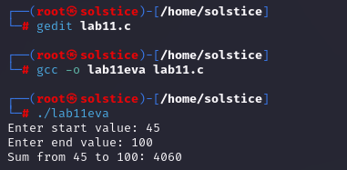

**Task 2**: Write a OpenMP C program in which you have a range of numbers, and you want to find all the even numbers in the range. The search operation can be parallelized using OpenMP to improve performance.

**Code:**

#include <stdio.h>

#include <omp.h>

int main() {

int start, end;

printf("Enter start value: ");

scanf("%d", &start);

printf("Enter end value: ");

scanf("%d", &end);

printf("Even numbers in the range %d to %d:\n", start, end);

#pragma omp parallel for

for (int i = start; i <= end; i++) {

if (i % 2 == 0) {

printf("%d\n", i);}}

return 0;

}

**Output:**

